OPERATING SYSTEMS

Lab Assignment-1

Adityan S Kumar

2301420004

**Experiment Title: Process Creation and Management Using Python OS Module**

**Task 1: Process Creation Utility**

INPUT-

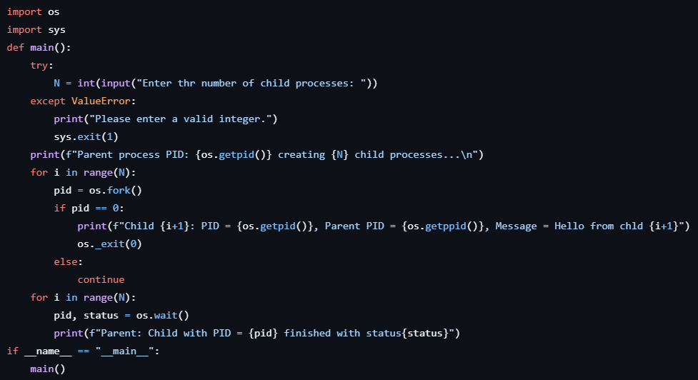

OUTPUT

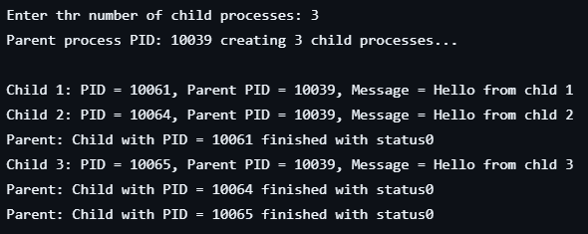

**Task 2: Command Execution Using exec()**

INPUT

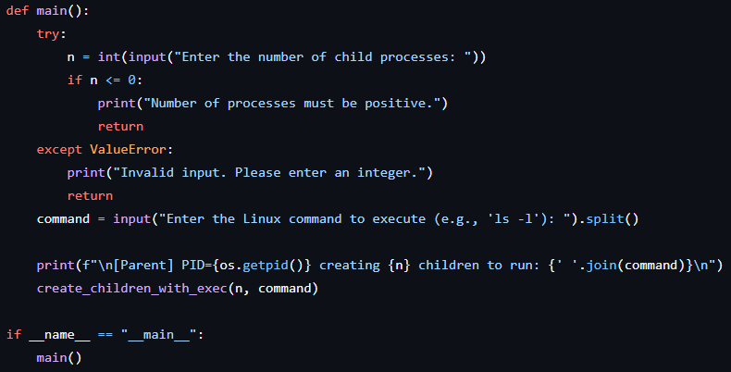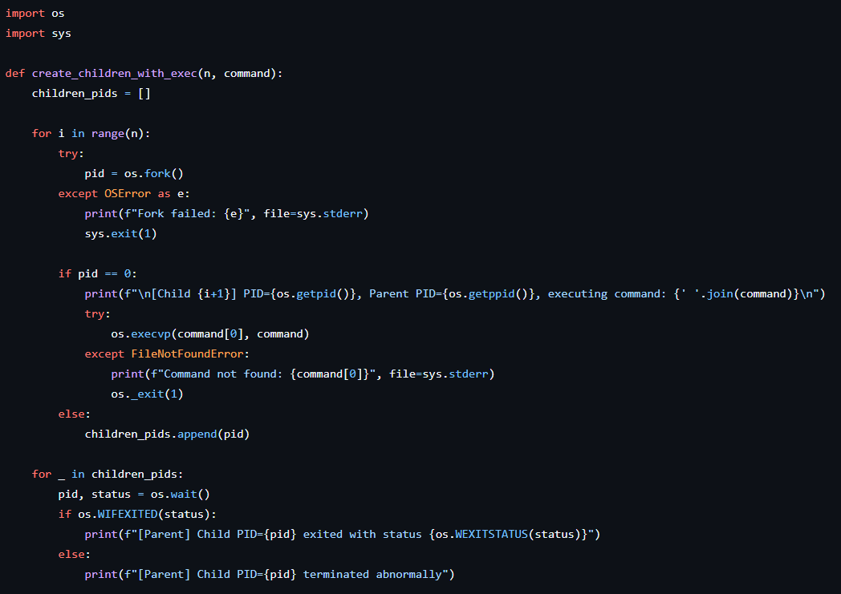

OUTPUT

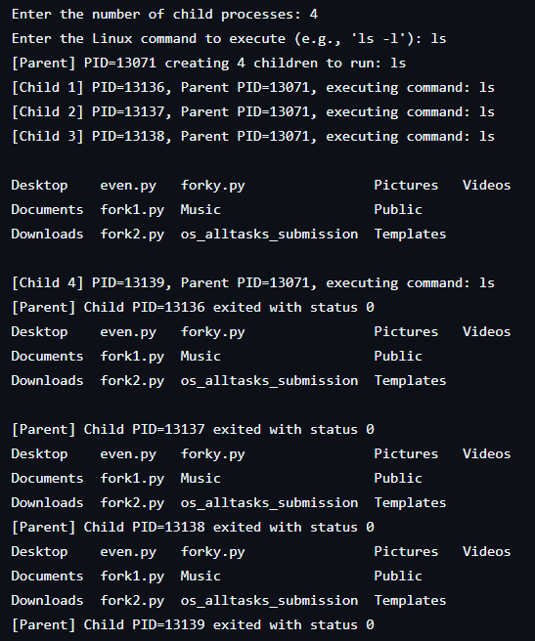

**Task 3: Zombie & Orphan Processes**

INPUT

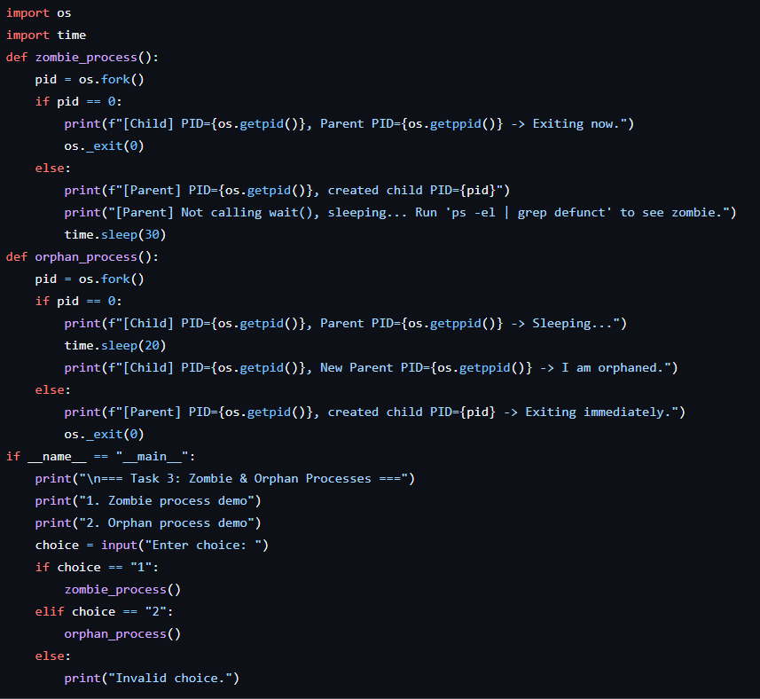

OUTPUT

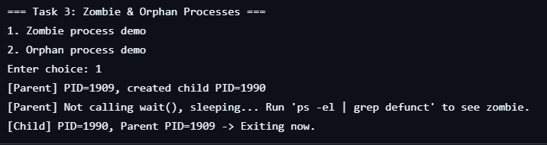

**Task 4: Inspecting Process Info from /proc**

INPUT

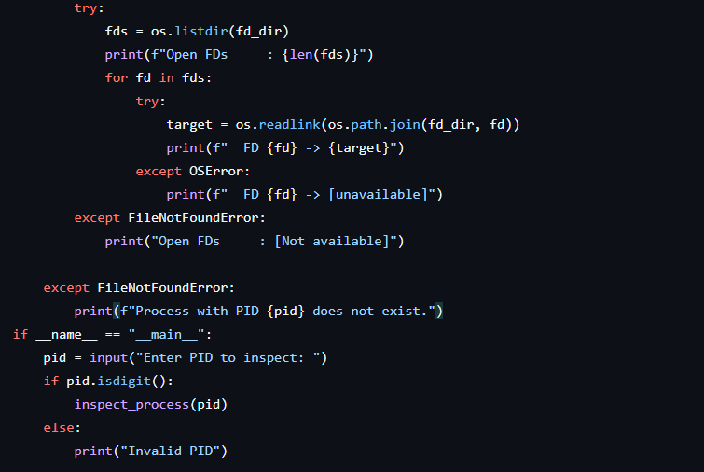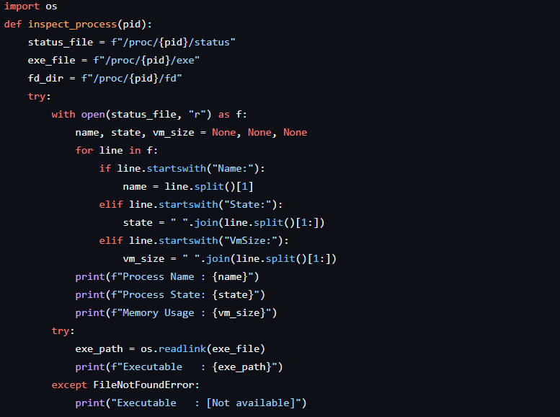

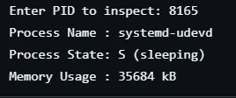OUTPUT

**Task 5: Process Prioritization**

INPUT

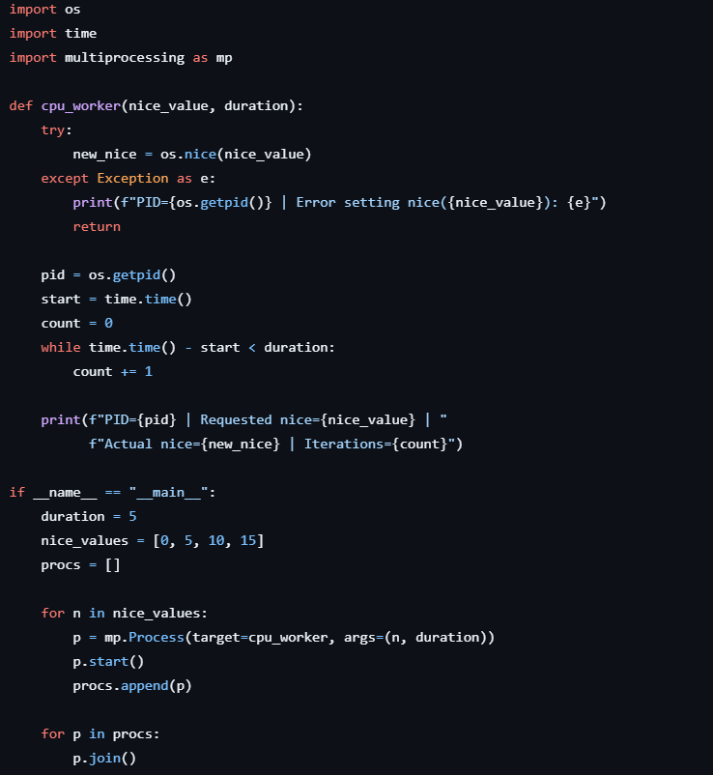

OUTPUT

